FAMILY & FRIENDS BINGO NIGHT 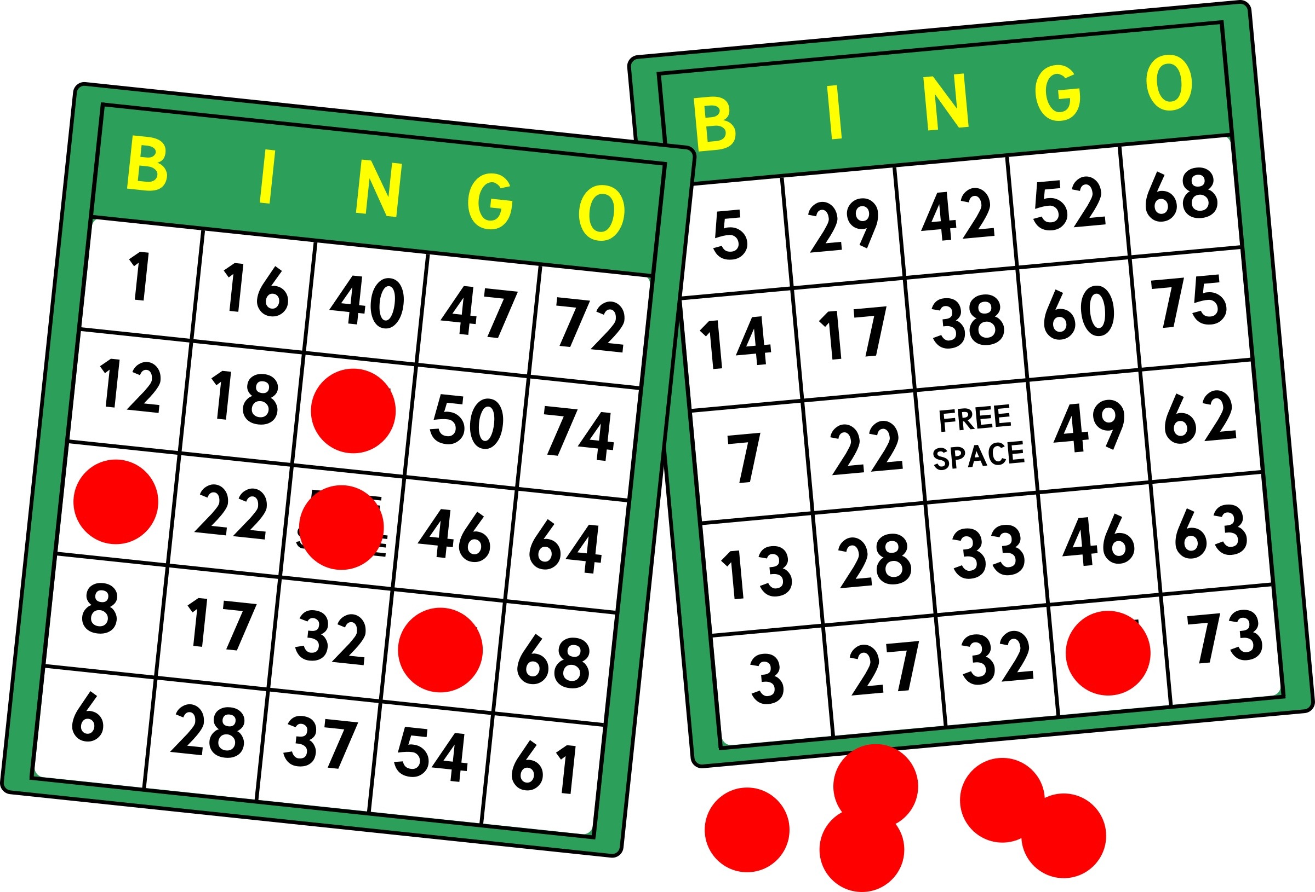

SSUMC’S United Methodist Women invite you to a night of fun & fellowship!
Join us for a spaghetti dinner & BINGO fun!
SUNDAY, FEBRUARY 11TH
5:30-7:30PM
Fellowship Hall
Bingo packets (4 games) - $5.00 each
Dinner, dessert & drinks - $5.00 each/$20 family max
(Vegetarian & Gluten-Free options available)
---------------------------------------------------------------------------------------------------------------------------------------------------------------
Name _________________________________________
Email _________________________________________
_____ Bingo Packets (4 games) x $5 each $________
_____ Spaghetti Dinner x $5 each ($20 max) $________
Total Payment $________
Make checks payable to UMW – return form with payment to church office by 2/9/18
**ALL PROCEEDS GO TO MISSIONS**

